**WEBAPDE – Mini Challenge #3 (Javascript)**

For this Mini Challenge, you are to simulate a shopping cart that is used by online shopping websites.

Interface

The shopping cart contains a series of elements, each of which may be styled to your liking. It is important that your shopping cart contains:

* An option to add items
* A text field to specify the quantity of the selected item
* Two buttons, for adding an item to the cart and for checking the item out
* A division which will display to the user the amount to be paid

See the sample screen shot below (The interface need not be followed)

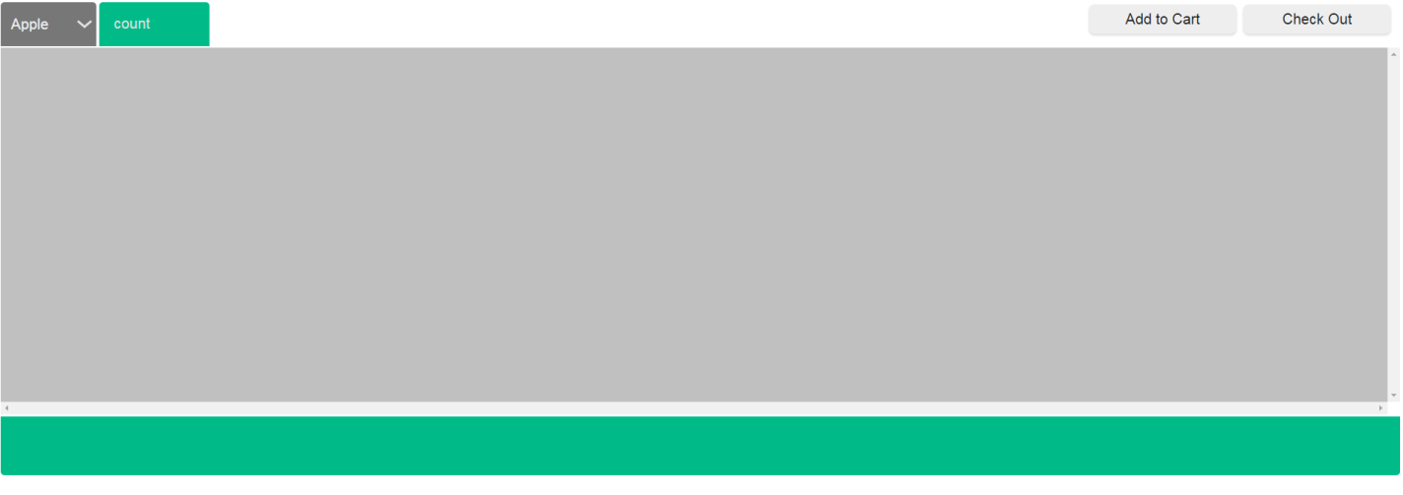

Interaction

The user is able to select items from a drop down list / through button image interaction / etc. and is able to specify how much of the item is going to be purchased. For this mini challenge, there will be 3 items that the user can purchase:

* Apple (Worth 20 each)
* Orange (Worth 10 each)
* Banana (Worth 30 each)

When the user is finished with their “Shopping”, the user should be able to determine the cost of their total transaction (Which is displayed when the user clicks “Check out”). Observe the sample interface on the next page

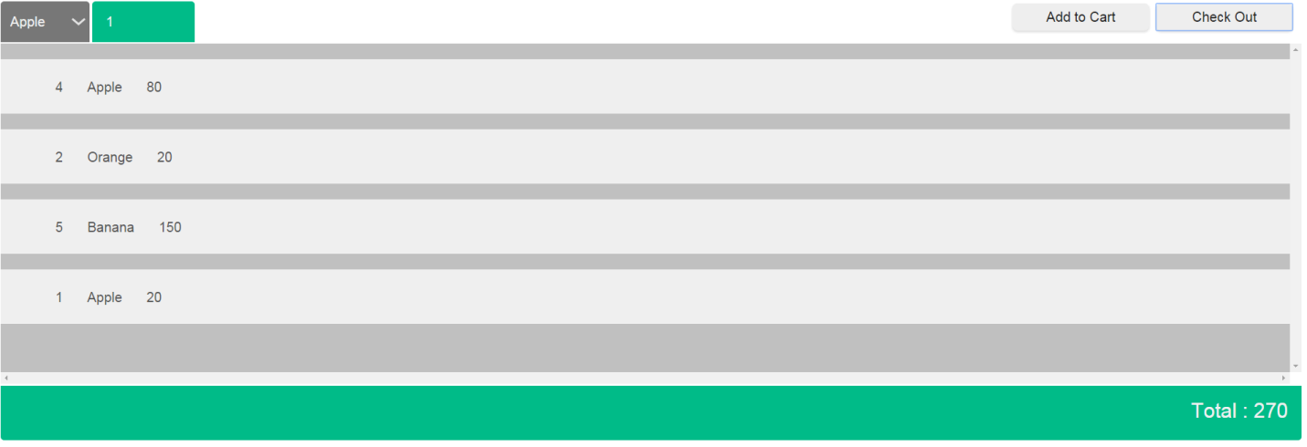

Submission Proper:

- For submission, place everything in a .zip file named your (group’s name).zip email it to [arturo.caronongan@delasalle.ph](mailto:arturo.caronongan@delasalle.ph)

- Email subject: MC3_WEBAPDE_<SECTION> (ex: MC3_WEBAPDE_S20)

- Email message body: The name of the proponents of the group.

- Submissions not received before the end of the day will receive corresponding deductions.